312/2
GEOGRAPHY
PAPER 312/2
END OF TERM ONE 2025
FORM 4 EXAM
Time: 2 ¾ hours
INSTRUCTIONS TO CANDIDATES
- This paper consists of two sections A and B answer all questions in section A
- In section B answer question 6 and any other two questions.
- All questions must be written in the answer booklet provided.
For examiner’s use only
Section A | 1 – 5
Section B | 6
Section B | 7
Section B | 8
Section B | 9
Section B | 10
TOTAL

Answer All Questions In Section A

- a).Give the relationship between Geography and Agriculture (2mks)
Agriculture is the cultivation of crops and rearing of animals. Geography studies farming systems, their distribution and the factors affecting farming activities.(2Marks)
b.).State three significance of learning Geography. (3mks)
Geography helps learners to develop skills which are used to study the environment.
It teaches methods of collecting and representing geographical information
It enables learners to understand and appreciate different environmental influences of societies
Encourages international awareness and cooperation
Geography teaches how to manage time properly
Geog is a tool of better citizenship
Geography is a career subject
Geography helps us to acquire positive attitudes and values in society.
(3 x 1 = 3Marks)
2 a). Distinguish between arable and livestock farming.
Arable farming refers to cultivation of crops while livestock farming refers to the keeping of livestock on the farm. (2Marks)
b). Give three economic factors that influence agriculture.
- Operational costs.
- Price fluctuations
- Marketing expenses
- Government policy (3 x 1=3Marks)
3.a) Identify two methods of underground mining (2marks)
- Shaft
- Adit
- Drilling
- Solution (3 x 1 =3Marks)
b) Three causes of land dereliction
- Failure of country to consider the consequences of mining instead focus on the benefits only
- lack of proper regulation to enforce rehabilitation.
- unwillingness by mining companies to engage in rehabilitation because it has no direct financial benefits. ( 3 x 1= 3Marks)

4. a). Name two exotic species of trees planted in Kenya
Pine , Cypress , Blue garm/eucalyptus , Wattle
Kei apple, Jacaranda, Bambax
Mango , Gravelie, Cedar ,Casuarina
(2 x 1 = 2marks)
b). State three reasons why it is necessary to carry out afforestation programmes in Kenya.
- To protect water catchment areas
- To protect soil from erosion by wind/water
- To ensure sustainable suppy of forest products
- To put land under forest cover to check desertifuication
- To check extinction of indigenous trees
- To regulate climate (3 x 1 =3 Marks)
5( a) .Name two provinces in Canada where wheat is grown in large scale
- Alberta
- Manitoba
- Saskatchewan (3 x 1=3Marks)
(b). State three physical conditions that favous wheat cultivation in Kenya
- Moderate rainfall/500mm- 1270mm pa
- Warm conditions/temperature of 15℃-20℃
- Volcanic soil
- Gentle sloping/ undulating landscape
(3 x 1 = 3Marks)

SECTION B
Answer question 6 and any other TWO questions from this section
6. Use the photograph below to answer question that follows

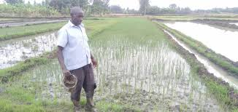
Name each of the following
a(i). Crop under cultivation
Rice (1Mark)
(ii). Type of farming
Canal irrigation (1Mark)
(iii). Other three crops grown together in this type of farming
- Tomatos, french beens, Banana, Peas maize Beans Vegetables Green gram ,Onion
- Water melon , Chillies, Capscicum
- Pawpaw (Any 3 x 1 = 3marks)
b). i) What type of photograph is shown
Ground general view photograph (1Mark)
ii). Draw a rectangle measuring 15cm y 10 cm to represent the area of the photograph. On it sketch anhd label the main features shown on the photograph
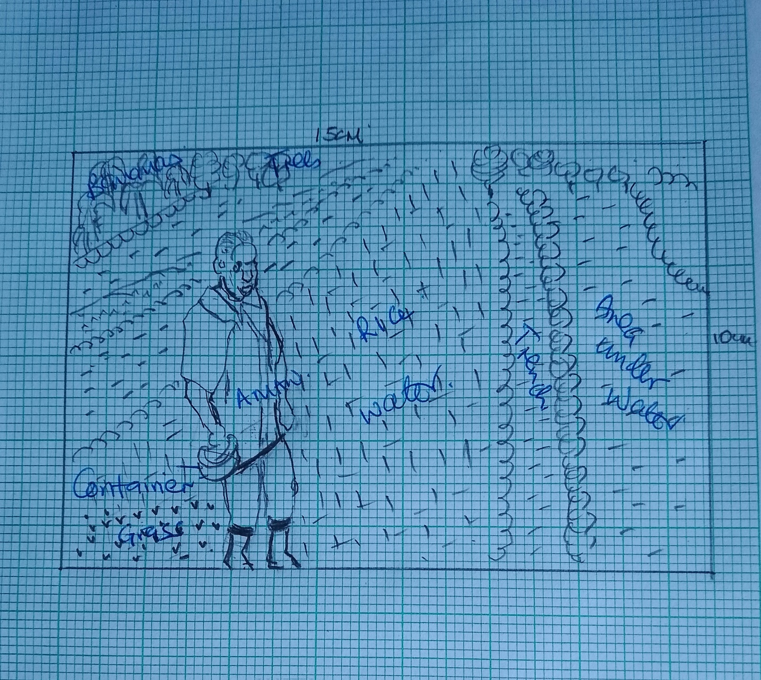
Features-Man/human being 1Mark
- Container 1Mark
- Area under water rice/planted crop 1Mark
- Banana plant 1Mark
- Trees 1Mark
- Trench 1Mark
- Horizon 1Mark total max 4 Marks
- Frame 1Mark =Total 5Mark
c. Explain four physical factors that influenced establishment of Perkerra irrigation scheme
- Availability of extensive land for irrigation/future expansion
- Presence of clay/alluvial soils that is rich in calcium phosphate that is ideal for growing of a variety of vegetables and fruits
- Availability on water from river Perkerra which is permanent and provide constant supply of water for irrigation
- Gently sloping land that allow irrigation by gravity flow of water
- Presence of semi- arid conditions which necessitate irrigation since rainfall is very low. ( 4 x 2 =8marks)
d). Describe the stages in the reclamation of land from the sea in the Netherland
- Part of the low lying land covered by sea water is enclosed using strong dykes
- Ring canal are dug on the inner side of the outer dykes to carry away excess water
- Water is pumped out from the enclosed part of the sea using wing mills
- Canal are then dug to drain the excess water from the enclosed land
- Chemicals are added to the soil to reduce salinity/ fresh water is pumped into the enclosed land to reduce salinity
- Oats, rye and sugar beets are planted to improve the Ph of the soil and reduce the water further. The land is dry and ready for use ( 6 Marks)
7a(i). Define the term mining
- Mining is the extraction of valuable minerals from the earths crust
(2Marks)
(ii). State four factors that influences the occurrence of minerals
- Vulcanicity leads to solidification of minerals I cracks and crevices
- Metamorphism leads to changes into new mineral formation of minerals
- Leaching results into concentration of minerals I the crust
- Erosion loosens minerals ad transport the eventually depositing them as alluvial deposits
- Sedimentation deposits accumulates ad concentrates minerals in specific areas making them occur in layers ends ad scams
- Evaporation enhances crystallization leading to formation of salts
- Weathering exposes minerals earth surface (Any 4 x 1= 4 marks)
(b). Describe the open cast method of mining
- The mineral deposit lies within few metres from the ground
- The unwanted material o the top layer /overburden is removed
- Soft mineral deposits are removed by drilling /scooping
- Hard minerals are removed by lasting with explosives
- The minerals is the scooped y excavator
- The mineral is loaded into Lorries / conveyor belt to e transported for processing
(5marks)
c). The map below shows location of minerals in East Africa, use it to answer questions (c
MAP OF EAST AFRICA
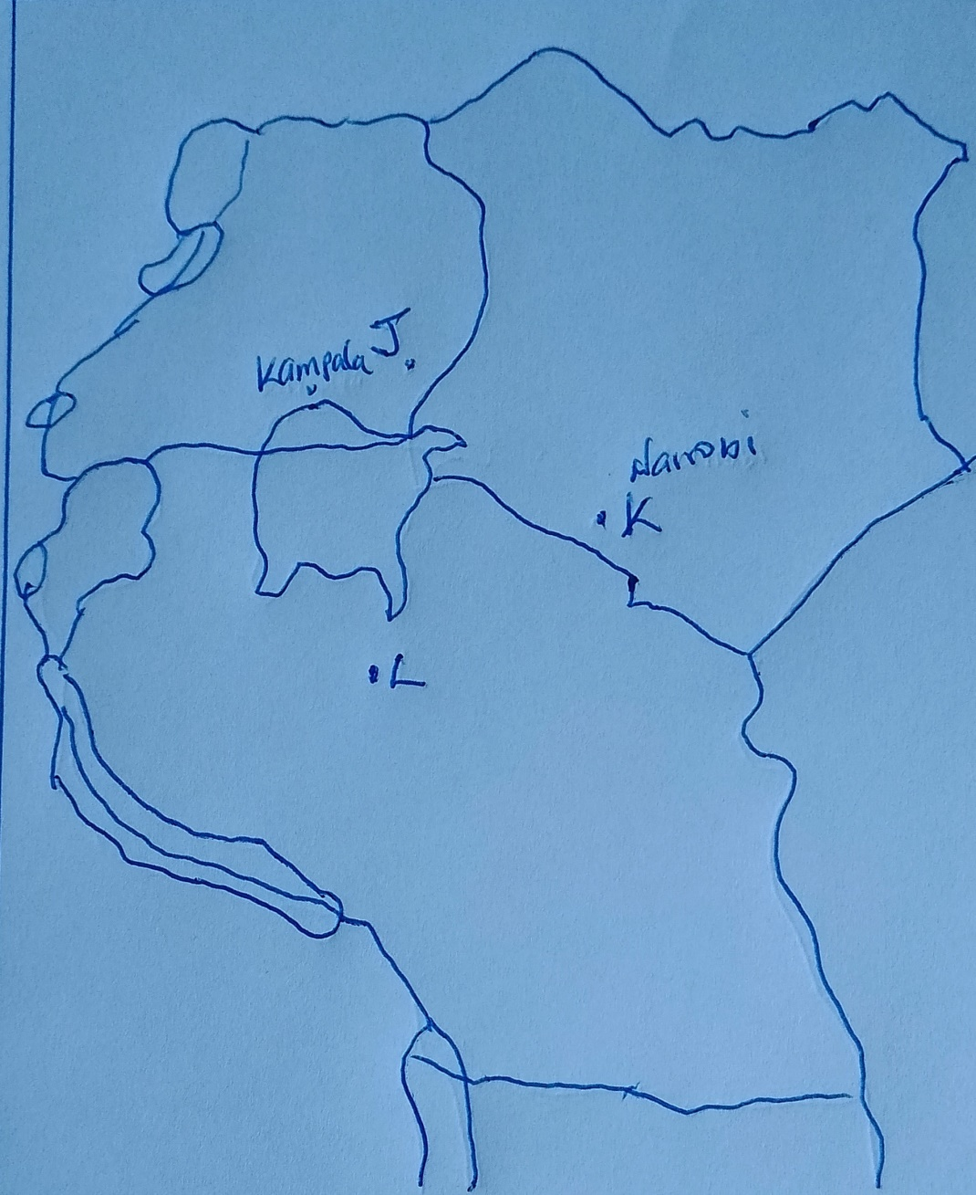
Name the minerals found I the areas marked J, K, L, and M
J- Limestone
K- Soda-ash/Trona
L- Diamond (3 X 1=3Marks)
ii). Describe the processing of Trona in lake Magadi
- Trona crystals are crushed ad mixed with lake water
- A mixer of Trona ad liquid pumped through a pipeline to soda ash factory
- Trona is separated from water by being put on large sieve like trays
- The Trona is washed to remove mud ad salts
- After drying Trona is heated in big cylinders ad it breaks into small particles of sodium carbonate/ soda ash
- Soda ash is allowed to cool
- It is the ground/weighed ad packed into paper bags ready for transportation to the market (5 x 1 =5marks)

Explain three ways in which mining promotes industrialization in Kenya
- Some minerals provide essential raw materials for some manufacturing industries
- Minerals are exported to ear the country foreign exchange which is used to develop other industries
- Mining stimulates development of roads/railways which promote industrial growth/ ease movements of raw materials
- Mining attract settlements/development of tows which attract
- Mining creates employments raising the living standards of people hence creating a greater demand for industrial products thus promoting industrial growth
- Mining has stimulated the growth of related industries y providing supplies or inputs/services. (3 x 2=6 marks)
8 (a). Name three types of dairy cattle kept in Kenya. (3marks)
- Fresians
- Aryshire
- Jerseys
- Guenseys (Any 3 x 1 = 3Marks)

(b)(i).State four conditions that favour dairy farming in Kenya highlands.
- Warm temperature / cool temperature averaging above 18⁰C.
- High rainfall of over 1000mm P.a evenly distributed throughout the year.
- Well drained deep soils which enables the growth of quality grass.
- Ready market available due to high population in the highlands and nearby towns.
- Good transport network in dairy farming areas to enable quick transport of milk to processing plants and markets. (Any 4 x 1 = 4Marks)
(ii) Explain three problems facing dairy farmers in Kenya.
- Insufficient feeds especially during dry season because our dairy farming is rain fed.
- Mismanagement of dairy cooperatives that have led to delay of payments to farmers hence affecting their role.
- Expensive farm inputs have lowered farmers’ profit margins.
- Impassable roads during rainy season which hinders delivery of milk to the factories.
- Shortage of proper storage facilities at collection centres results in milk going bad before getting to factories.
- Diseases such as East Coast Fever and Pests such as ticks results in death of animals. (Any 3 x 2= 6 Marks)
(c)(i).State three measures the government of Kenya is taking to improve dairy
farming.

- Encouraging the farmers on the use of artificial insemination in order to improve quality of breeds kept.
- Encouraging farmers to grow fodder crop than depend on natural pasture.
- Revamping New KCC as a market and improving milk prices in motivator.
- Training farmers through seminars and workshops on scientific methods of doing farming such as zero grazing.
- Constructing new roads and improving existing ones to facilitate transport of milk to the market.
(Any 3 x 1 = 3Marks)
(ii) ) Compare dairy farming in Kenya and Denmark.

- In Kenya it is carried out mainly in the highlands while in Denmark, it is carried out throughout the country.
- In Kenya farmers mainly depend on natural grass while in Denmark, farmers depend on fodder and commercial feeds.
- In Kenya, mechanization is used on large-scale farms and manual on small scale while in Denmark, mechanization is widely used.
- In Kenya, farmers practice mixed farming while in Denmark, farmers are specialized.
- In Kenya, most dairy cooperatives have suffered mismanagement and do not have enough funds to assist the farmers while in Denmark, Dairy Cooperatives are highly managed and developed to provide services to farmers. (any 2 x 2 = 4mks)

(d) (i) You intend to carry out a field study in a dairy farm.
(i) Give three methods you would use to collect information. (3mks)
- Observing
- Interviewing Interviewing
- Use of questionnaires
- Sampling
- Photographing / video taking
- Counting (any 3 x 1 = 3Marks)
(ii) State two follow up activities you would carry out after the field study.(2mks
- Analysing
- Presenting
- Interpretation
- Discussing the findings.
- Writing reports.
- Displaying photographs / samples.
- Drawing maps, tables, graphs and charts.
- Group reports. (any 2 x 1 = 2Marks)

9. (a) A part from the palm oil, name three other products of oil palm tree
- Dry leaves are used to thatch traditional shelters
- Dry leaves are used to make brooms
- Kennels and dry stalks used as source of fuel
- Other waste materials are used to make animal feeds and composite manure (3×1=3 Marks)

b). State five characteristics of shifting cultivation
- Vegetation is cleared by slashing and burning
- There is the use of little or no manure/ use of cash
- The land is communally owned
- The land is abandoned when the yields decline
- Both the settlements and lots are temporary
- Farming depend mainly on family labour
- The farmer use simple implements
- It is mainly for subsistence
- Plots are small and scattered (5 x 1 =5marks)
c). Identify three environmental conditions that affect coffee growing in Kenya
- Inadequate rainfall in some areas which leads to heavy losses
- Diseases eg root rot, coffee berry disease attack the lowering the yields
- Pests such as leaf minor/ alphids/ ladybird thrip attack the crop lowering the yield. (3 x 1 = 3 Marks)
(d) Describe the stages involved in coffee production from harvesting to marketing.
- The ripe /deep red berries are picked by hand.
- The harvested berries are carried in sacks to the factory.
- The berries are sorted out to remove the unripe /diseased berries.
- The berries are graded in to grade A and B.
- The different grades are weighed.
- The berries go through a machine that removes the outer covering /pulp.
- The beans are fermented in tanks for some time.
- The beans are washed and sun-dried for about a week.
- The husks are removed and the beans winnowed.
- The beans are sorted out and graded according to size and quality.
- The beans are roasted at temperatures of about 100^{oc}.
- The beans are ground into powder and packaged ready for sale.
(7 x 1 =7marks)
bii.)Explain four measures taken by the government of Kenya to assist maize farmers
- Buying maize grain from farmers through national cereals and produce board at fair prices in-order to protect them from exploitation from middlemen
- Selling to farmers farms inputs/fertilizers at subsidized prices to enable them induce their cost of production
- Advancing credit through AFC/ other agencies to assist farmers buy farm inputs and improve quality of their products and quantity of production.
- Educate farmers/ provide extension services on better methods/ seeds to use in-order to improve quality of their products/ better quality
- Conducting research on better maize seed that farmers can use in different environmental conditions for higher yields
(4 x 2 = 8 marks)
10. a).i). Differentiate between indigenous and exotic forests.
- Indigenous forests is a forest that is made up of trees which are native/natural to a country/region while exotic forest is a forest that is composed of trees that are alien to a country
(2 marks)
ii). State four factors that lead to depletion of forests in Kenya.
- The government policy of degazetement has allowed illegal cultivation and settlement in forest areas.
- Increased population of elephants that destroy trees
- Prolonged droughts have caused drying up of some trees.
- Plant diseases and pests destroy parts of forests.
- Over exploitation of certain species of trees
(4 x 1 =4marks)
b). Explain three factors that favour the growth of natural forests on the slopes of Mt. Kenya.
- The area receives high rainfall/1000 mm-2200mm throughout the year which
- encourages continuous growth of trees.
- The area has deep fertile volcanic soil that allow the roots for penetration deep
- into the ground support trees.
- The area is a gazetted reserve prohibiting cultivation and settlement hence
- allowing growth of trees
- The steep slopes discourage settlement thus forests thrive.
( 3 x 2=6marks)
c). Compare forestry in Kenya and Canada under the following headings;
i). Mode of exploitation
In Kenya workers are transported to the logging sites daily while in Canada logging involves setting up a settlement for workers within a region to be harvested.(2Marks)
ii). Transport
In Kenya transportation is mainly by road transport while in Canada transport is mainly by water transport. (2Marks)
d). i). State three factors favouring the development of softwood forests in Canada.
- Cool to cold climate favours the growth of coniferous trees
- Rugged landscape and steep slopes discourages agriculture and settlement hence forests establish themselves naturally
- Canada has a low population density hence a lot of land for forestry
- Presence of heavy rainfall on the windward slopes of mountain ranges supports tree growth
(3 x 1= 3marks)
ii). Explain three measures used to conserve forests in Kenya.
- Mature trees felled are replaced immediately.
- Tree farming is practiced in many parts with the aim of raising trees for future use.
- Regions which previously were devoid of trees are being planted with trees
- People are now being encouraged to plant trees and food crops in the same farms.
- The reduction of wastage e.g. the use of waste paper to produce newsprint.
- People are required to seek permits if they have to cut trees. This reduces the rate of trees felling/unlicensed people do not cut down trees.
- The forest reserves are patrolled by guards to ensure that fires are reported promptly and also to ensure unlicensed people do not cut down trees.
- Forest reserves have been set aside to conserve indigenous species.
- Forestry department of the ministry of natural resources carry out research to produce and distribute seedlings to ensure the extension of forests.
- People are being educated through mass media on the importance of trees
(3 x 2=6 marks)

………………E N D……………..

